Challenge-03-TH

Launch oneEC2 instanceusingAmazon Linux 2.
- Login to AWS Console
- Click Launch Instance
- Add instance name
- Connect to Amazon Linux 2 instance
- SSH from terminal
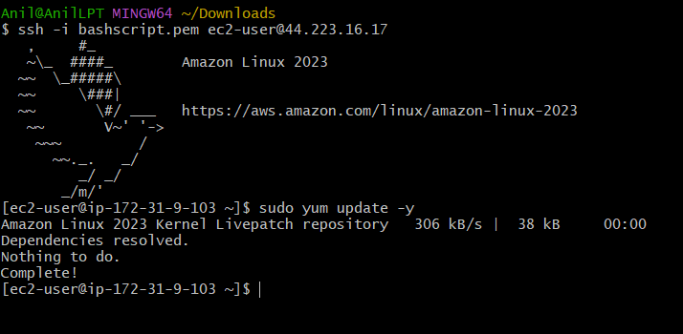

- InstallDocker.

- sudo yum update -y
- sudo yum install docker -y
- sudo systemctl start docker
- sudo systemctl enable docker
- sudo systemctl status docker

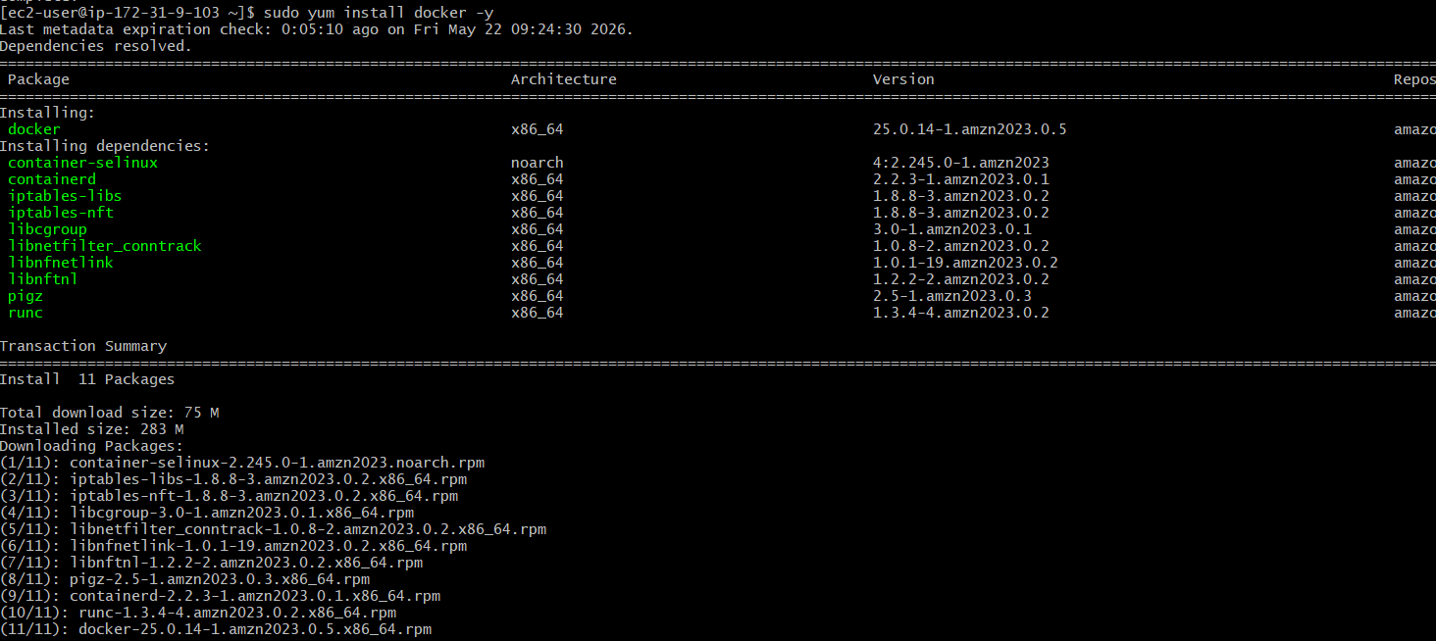
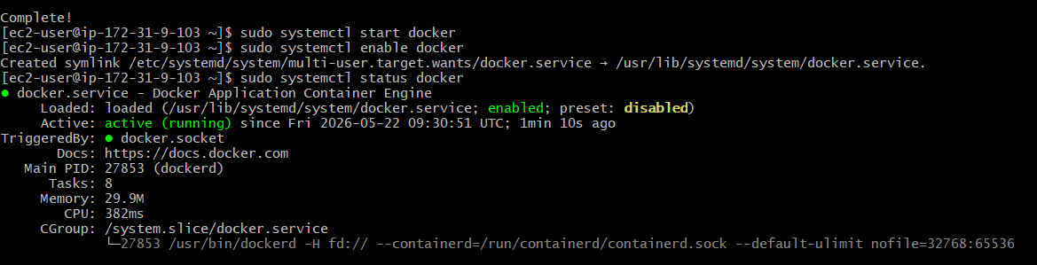

- InstallJenkins.

Install Java - sudo yum install fontconfig java-21-openjdk -y
By default, Amazon Linux does not know where Jenkins package is located ,that is why you this error No match for argument: Jenkins
/etc/yum.repos.d/jenkins.repo (helps you download repo in to )
Without the repo, Linux searches only default Amazon repositories, and Jenkins is not there
sudo rpm --import https://pkg.jenkins.io/rpm-stable/jenkins.io-2026.key This key is used to verify that the Jenkins package is trusted and really coming from Jenkins.

Then install Jenkins and start ,check status

Open port 8080 in AWS Security Group
Open Jenkins in browser http://your-public-ip:8080
Get initial Jenkins password
sudo cat /var/lib/jenkins/secrets/initialAdminPassword
Finish Jenkins setup

- 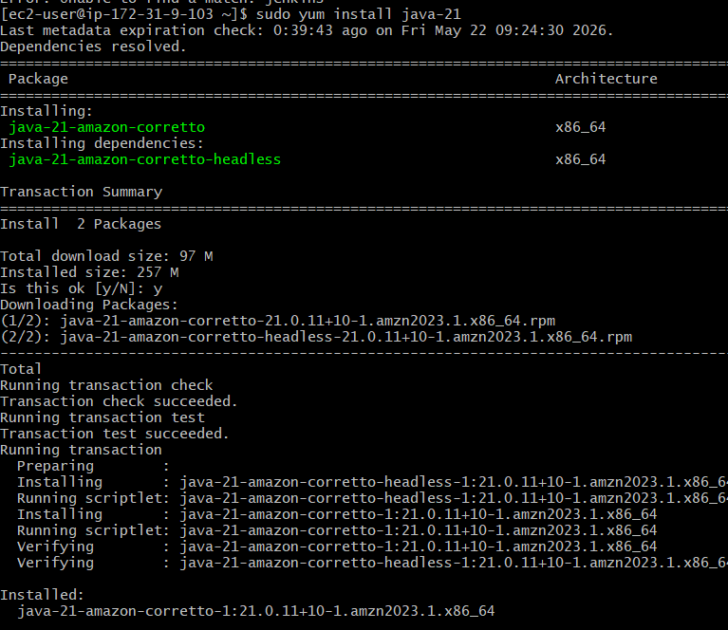
- 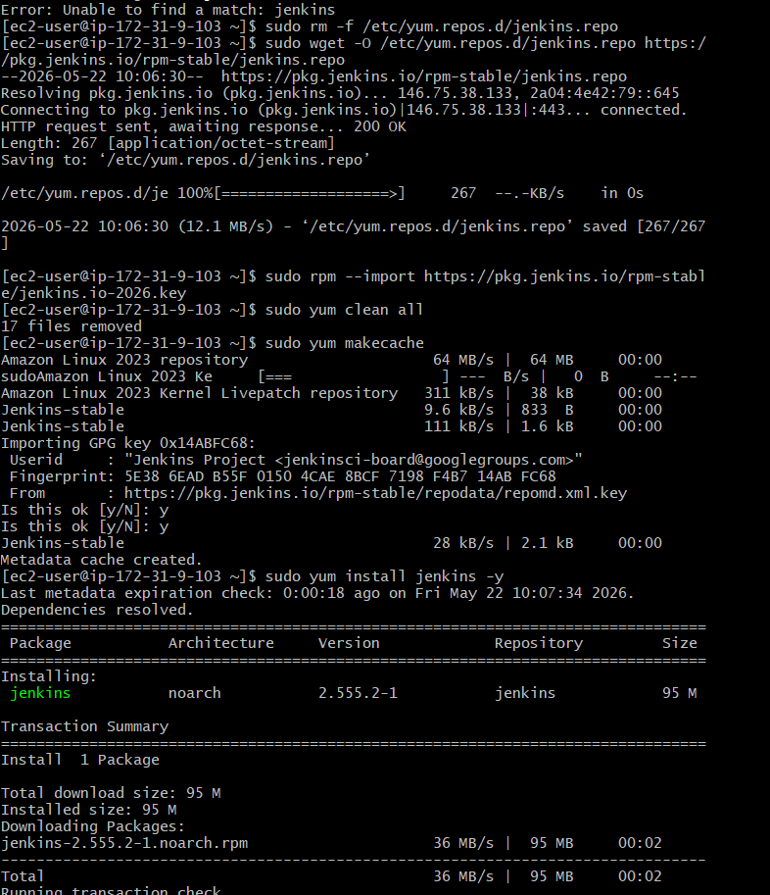
- 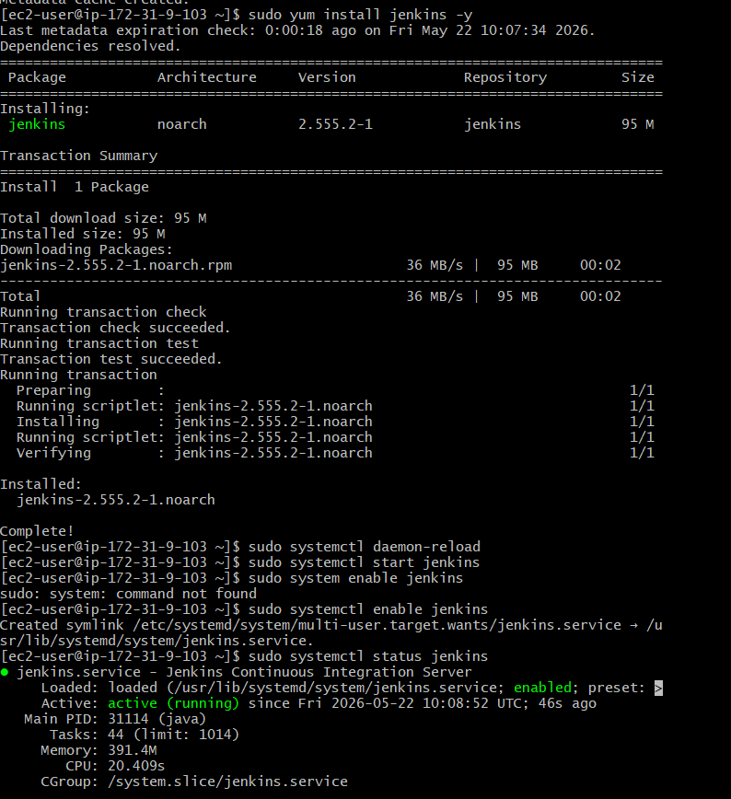

- 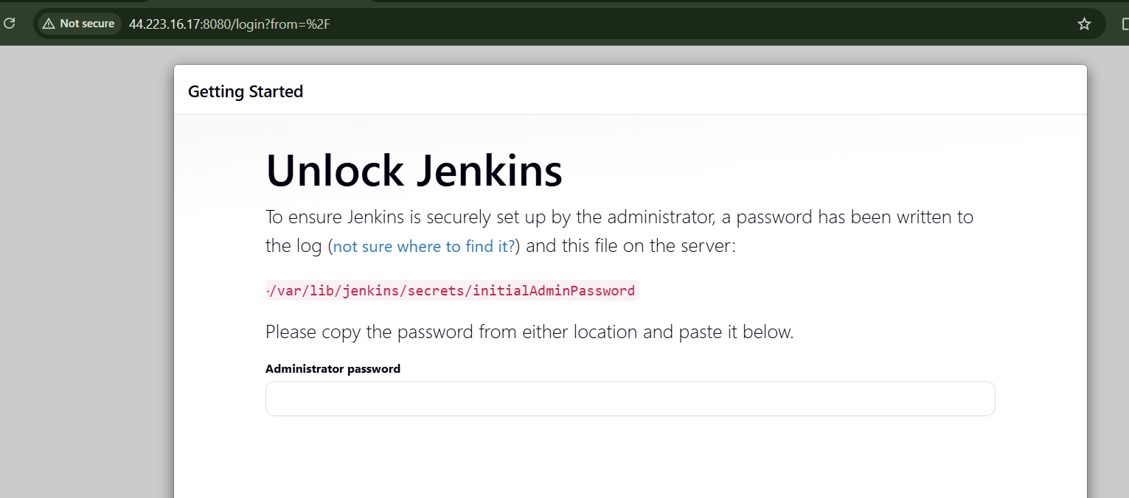
- 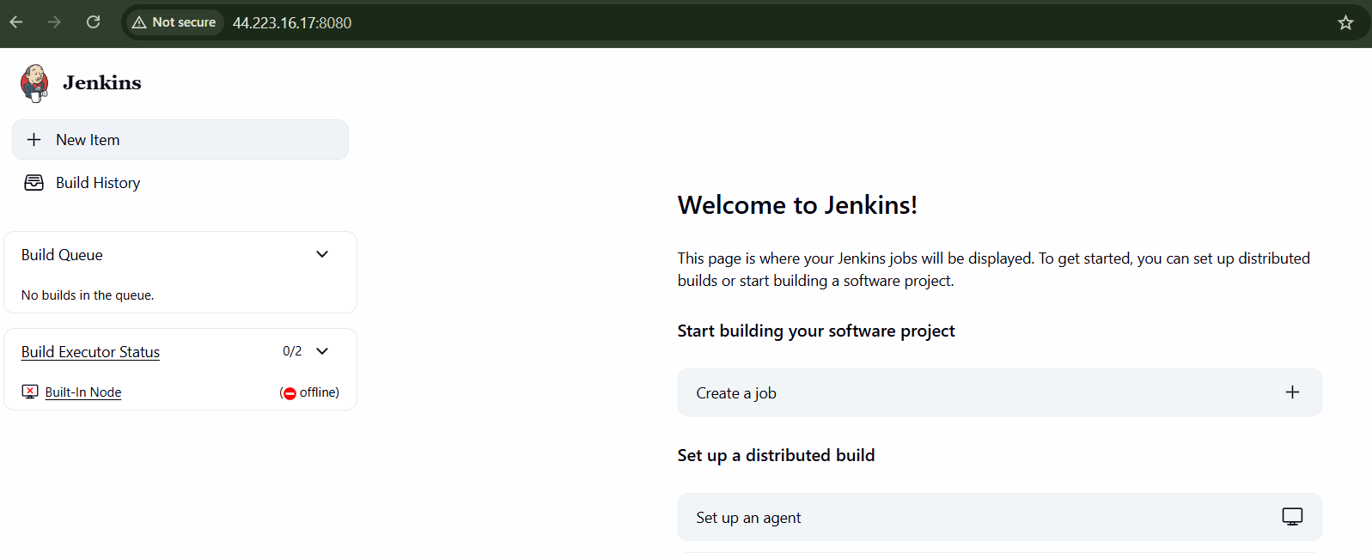

InstallApache.

sudo yum install httpd
systemctl start httpd
systemctl enable httpd
systemctl status httpd
check in the web server with port 80

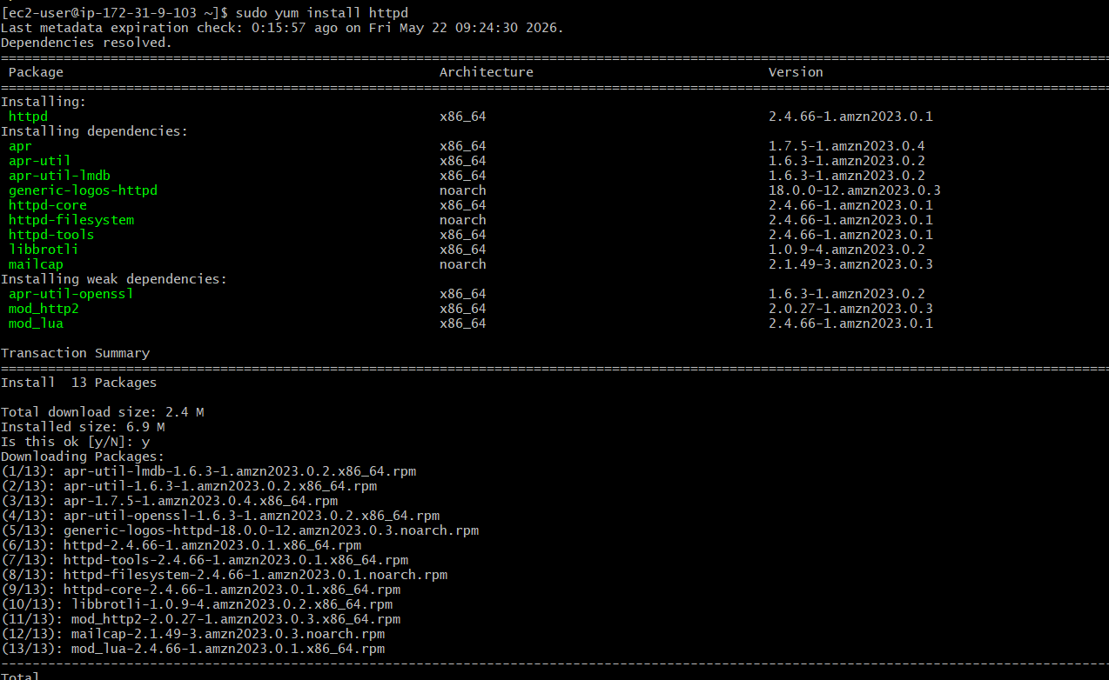

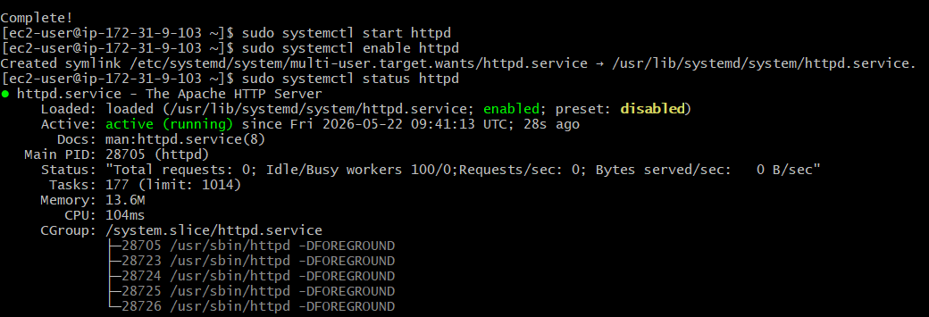

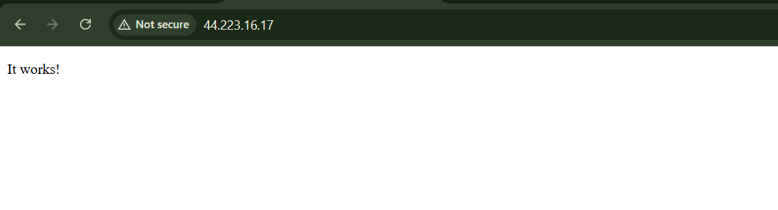
- InstallNginx.

Sudo yum install nginx -y
Systemctl start nginx
Systemctl enable nginx
Systemctl status ngnix

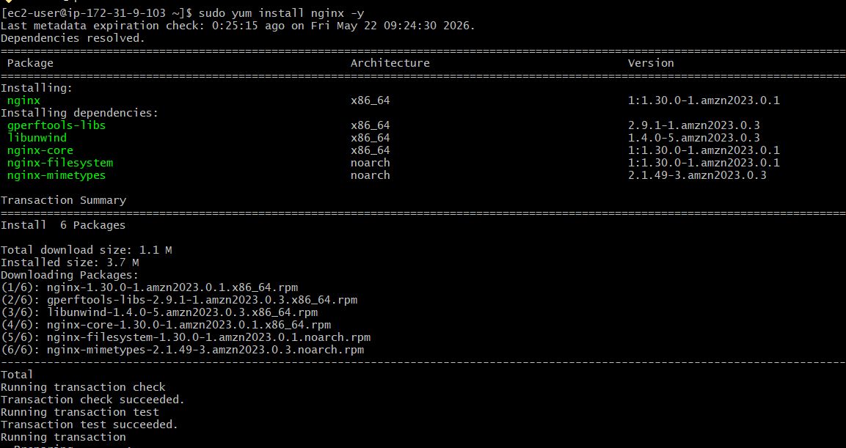
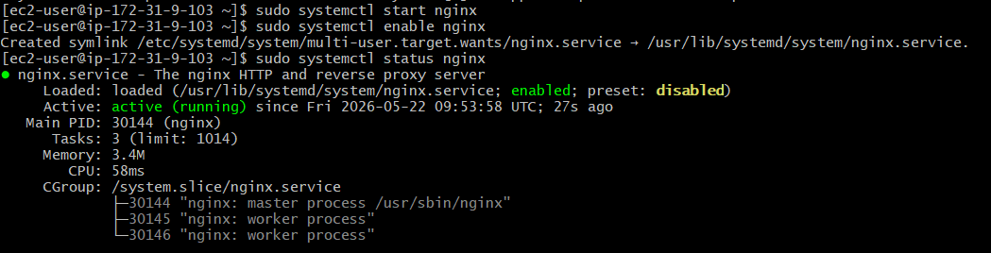
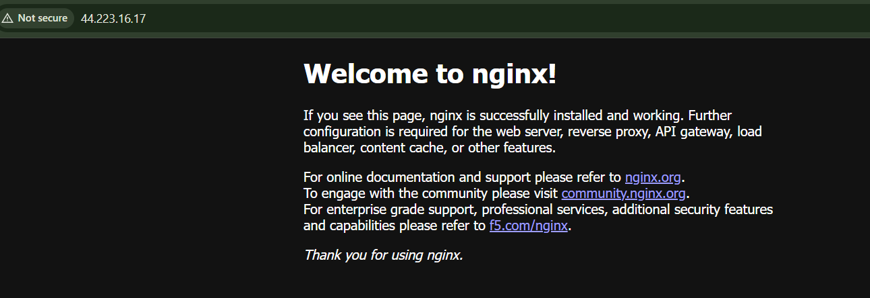

- InstallApache Tomcat.

- You installed Tomcat manually in:
- /opt/tomcat
- So normally you start Tomcat like this:
- sudo /opt/tomcat/bin/startup.sh
- But this is a manual start.
- If the server reboots, Tomcat will not start automatically unless you create a service file.
- To control Tomcat like a real Linux service, we create a file: /etc/systemd/system/tomcat.service
- For Tomcat, the service file tells Linux:
- Tomcat is installed in /opt/tomcat
Java is installed in /usr/lib/jvm/java-21-amazon-corretto.x86_64
Start command is /opt/tomcat/bin/startup.sh
Stop command is /opt/tomcat/bin/shutdown.sh
- Stop manually running Tomcat - sudo /opt/tomcat/bin/shutdown.sh
- Check if Tomcat stopped: sudo ss -tulpn portnumber
- : Check Java path - readlink -f $(which java)
- Create Tomcat service file- sudo vi /etc/systemd/system/tomcat.service
- Reload system - sudo systemctl daemon-reload
- Start Tomcat using systemctl
- Check Tomcat status
- Enable Tomcat on server reboot - sudo systemctl enable tomcat
- Confirm Tomcat is listening on port 8081
- Test inside the server- curl -I http://localhost:8081

- 
 